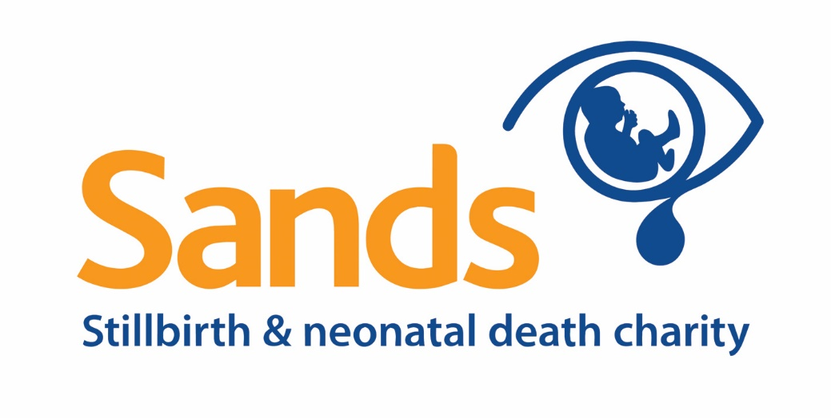

PRESS RELEASE
[INSERT DATE]

[FUNDRAISER NAME] is raising money for Sands by [INSERT DESCRIPTION OF HAIR-RAISING ACTIVITY]
[FUNDRAISER NAME] will be raising funds for Sands by [INSERT DESCRIPTION OF HAIR-RAISING ACTIVITY e.g shaving off all her hair having grown in it for over a year! OR the whole family are dying their hair and orange for Sands] on [INSERT DATE] and they will be streaming all of this online. During the live stream [FUNDRAISER NAME] will ask for sponsorship by sharing their online fundraising page [INSERT LINK TO FUNDRAISING PAGE].

[FUNDRAISER NAME] has chosen to support Sands because [INSERT FUNDRAISER’S REASON FOR SUPPORTING SANDS IF COMFORTABLE].

Sands has far reaching impacts locally and nationally, supporting bereaved parents, families and healthcare professionals when the worst happens.

The death of a baby is life changing for families and excellent care is crucial to their long term wellbeing.
Supporting bereaved families can be challenging for professionals who are also trying to manage their own emotions and may feel unprepared and daunted.
Now more than ever, Sands is here to support all staff working in hospitals and for the NHS to equip them with the confidence and skills to care for families when the worst happens.

For further information on Sands’ Hair-raising fundraising activities please go to: https://www.sands.org.uk/hair-raising

For further information on the impact Sands has please read our Impact report by going to this link: https://www.sands.org.uk/about-sands/how-your-support-makes-difference/sands-impact-your-impact

-Ends-
Notes to editors
For further information please contact our Press and PR Team on 0207 436 7940 or email fundraising@sands.org.uk

Sands’ history
In the mid-1970’s two women – Hazelanne Lewis, a psychiatric social worker, and Bel Mooney, a journalist – both gave birth to stillborn babies. At that time, most parents were not allowed to see or hold their babies, no pictures were taken and they were not told where their babies were buried.

Using her professional standing to break the silence around baby loss, Bel wrote a story for The Guardian describing her own experience, while Hazelanne wrote to national newspapers asking bereaved parents to share their stories. The avalanche of replies from all over the UK revealed the vast, unrecognised need for support and advice for bereaved parents and their families upon the death of their baby.

These two women sparked the discussion of the many difficulties in overcoming prejudice against openly acknowledging the death of a baby and the pain of bereavement. As a result, the National Stillbirth Study Group was set up in 1977, comprising of various health professionals and representatives from other bereavement support groups, who produced an information booklet for bereaved parents. It was this impetus that would form Sands.

About Sands
Sands is the leading stillbirth and neonatal death charity in the UK. They work nationally to reduce baby deaths through promoting better maternity care and funding research. They have a programme of training and a wide range of resources designed to support professionals to improve the bereavement care they provide following the death of a baby, and they provide a comprehensive bereavement support service both nationally through their helpline and locally through around 100 regional support groups based across the UK.

Further information can be found at www.sands.org.uk

