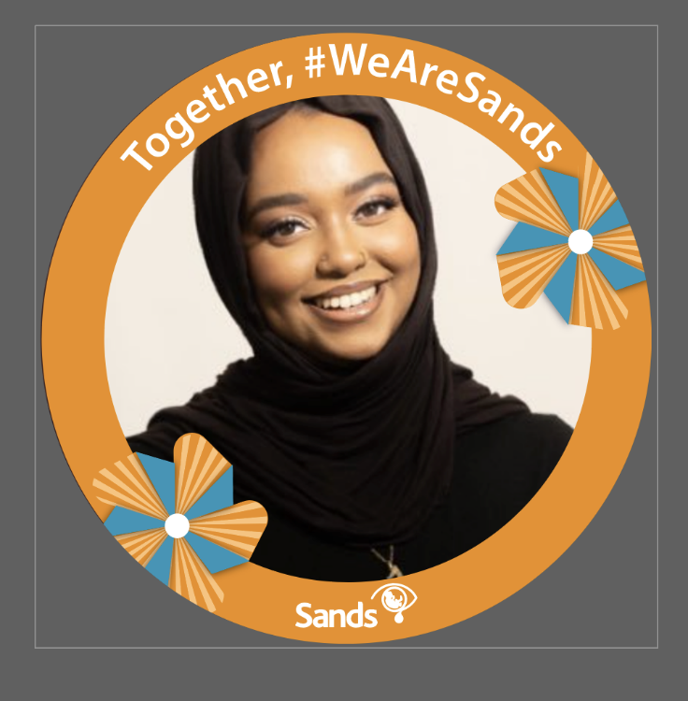

Twibbon Instructions

What is a Twibbon?
A Twibbon is a small image that you can overlay onto your Twitter or Facebook profile picture in order to support a campaign. An example is shown below.

Why should I use one for Together, we are Sands?
Using a Twibbon shows your support for a campaign or cause to your followers. If they like the cause they can also use the Twibbon and so the awareness spreads. Sands has designed a Together, we are Sands Twibbon which you can download and put on your social media profiles.

How do I use the Together, we are Sands Twibbon?
Just follow these steps:

- Go to https://twibbon.com/support/together-we-are-sands
- You are given the option of adding the Twibbon to Twitter or Facebook. You can do one or the other or both.
- Authorise Twibbon to access your account. This does not risk compromising your account security, it just lets all your contacts know that you are taking part.
- You have the option to add a few words explaining why you are supporting Together, we are Sands campaign. This forms a tweet or post for your feed.
- Once happy with your message press either the post or tweet button.
- You are then asked to sign into your account. Follow the instructions that come up regarding your account. You will then receive confirmation that the Twibbon is loaded on your account.

How do I take the Twibbon off?

If you've added a Twibbon on Facebook, you can remove it by:

- Visiting your profile pictures album on Facebook
- Opening your previous profile image (without the Twibbon)
- Setting this image as your profile picture

If you have added a Twibbon on Twitter, you can remove it by:

- Going to your profile page on Twitter and clicking the Edit Profile button on right hand side of the page
- Clicking “Change your profile photo”
- Choosing the option to upload photo
- Choosing your previous profile photo from your computer without the Twibbon overlaid
- Once you are happy with the positioning, clicking “Upload”
- Clicking “Save Changes”

You can load the Twibbon onto your account at any time to show you are part of the Sands community. Please help us to reach even more people and spread the campaign as widely as possible! Please ask your staff, family and friends to join our campaign.

If you have any queries then please contact communicationsgroup@sands.org.uk

